***Assignment 5***



Name:

FCU ID:

Team number:

**Topic of this class: Real world analysis project**

Data analysis is a scientific way to study a project. It can be described as the breaking down of an object, system, problem or issue into its basic elements to get at its essential features and their relationships to each other and to external elements.

Problems are often presented to the innovators in the form of questions such as:

* How much ... is needed to ...?
* Is ... strong enough?
* What will happen if ...?

The problem solving process that follows is usually to formulate a mathematical model of the situation in terms of algebraic or differential equations and then obtain quantitative estimates of key parameters within the model. These parameter estimates, together with some critical judgement, are then used to provide an answer to the original question.

|  |
| --- |
| **Learning objectives:**  *New abilities:*   * **UC03:** Define systems or processes with mathematical models with simulation results. * **UC04:** Calculate efficiency of a system, product, or process as it relates to cost, energy, or other engineering factors.   *Review what you learn before:*   * **ET03:** Justify graphical representation based on data characteristics. * **ET04:** Prepare chart or table for technical presentation with proper formatting (headers, units, meaningful decimal points, appropriately scaled axes, appropriately sized marker and axis labels). * **ET05:** Create a histogram with meaningful number of bins and width/sizes. * **DA01:** Describe, with calculations, the central tendency of data using descriptive statistics (mean, median, and mode). * **DA02:** Describe, with calculations, variability of data using statistical methods (standard deviation, variance). * **DA03:** Make accurate comparisons across groups with explicit reference to data. * **DA04:** Given independent and dependent variables, interpret or predict the performance of a solution. * **DA05:** Given two variables, describe the relationship and/or calculate the strength of the correlation between these variables. * **DA06:** Interpret the distribution of data in a graph * **PC01:** Use professional communication (written, visual, and oral), free of grammatical or spelling mistakes and in a formal tone, appropriate for engineering school and workplace. * **PC02:** Make clear and complete arguments or statements by fully addressing all parts of the assignment. * **SQ01:** Use accurate, scientific, mathematical, and/or technical concepts, units, and/or data in solutions. * **SQ02:** Justify design solution based on how well it meets criteria and constraints. * **UC01:** Demonstrate an understanding of conservation principles (mass, energy, momentum, and/or charge) in a boundary system. * **UC02:** Describe systems or processes using schematic diagrams with inputs, outputs, and accumulations. * **PA01:** Identify strengths and limitations in one’s problem solving/design approach.   ***You will be graded on completion of the above objectives!*** |

1. **Team activity: Data analysis project 1 (simple case).**

The GISS Surface Temperature Analysis (GISTEMP) is an estimate of global surface temperature change. The basic GISS temperature analysis scheme was defined in the late 1970s by James Hansen when a method of estimating global temperature change was needed for comparison with one-dimensional global climate models. (<https://data.giss.nasa.gov/gistemp/>)

Evaluating the temperature of the entire planet has an inherent level of uncertainty. Because of this, the data set provides values that describe the range of this uncertainty, or simply "range", of each month's, season's or year's global temperature anomaly. These values are provided as plus/minus values.

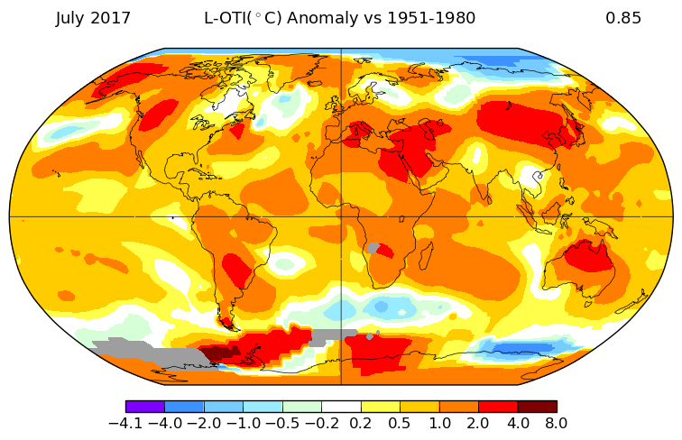

Base on the data set “Assignment 5 - case 1_global_surface temperature_data.xlsx”, try to write an Data analysis report. In the report, you need to:

1. Choose 3 countries from each of the selected five continents (Asia, Europe, Africa, North America & South America), and 3 cities from each country you chose.
2. Present the surface temperature variation from 1960 to 2010.
3. Both diagrams and text description.

**Answer columns:**

|  |
| --- |
| 1. **Data analysis report 1 - Global surface temperature** |
|  |

1. **Team activity: Data analysis project 1 (complex case).**

A fireball is an unusually bright meteor that reaches a visual magnitude of -3 or brighter when seen at the observer’s zenith. It explodes in the atmosphere are technically referred to as bolides although the terms fireballs and bolides are often used interchangeably.

A world map shows a visual representation of the data table that provides a chronological data summary of fireball and bolide events provided by U.S. Government sensors. (https://cneos.jpl.nasa.gov/fireballs/intro.html)

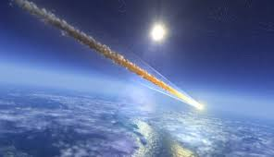

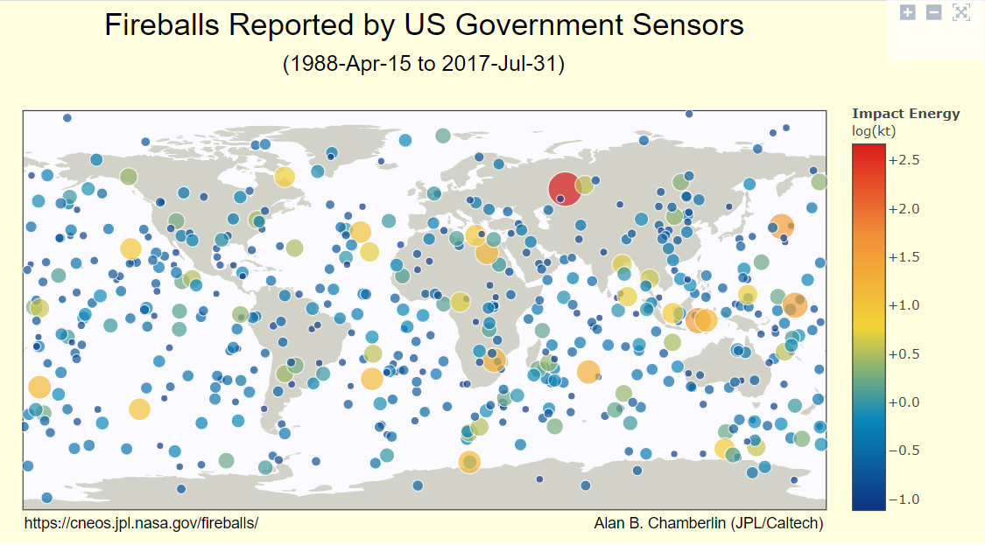

The approximate total radiated energy in the atmosphere is provided in unit of Joules, a unit of energy given in kilograms times velocity squared, or kg x (m/s)2. An event with an energy equivalent of one thousand tons of TNT explosives is termed a kiloton (kt) event, where 1 kt = 4.185 x 1012 Joules.

The total radiated energy is given but this is always less that the total impact energy. Peter Brown and colleagues have provided an empirical expression to approximately provide the total impact energy in kt (E), given the optical radiant energy in kt (Eo)

**E = 8.2508 x Eo0.885**

Try to write an Data analysis report about fireball events based on “Assignment 5 - case 2_cneos_fireball_data.xlsx”. The following descriptions of fireball events must be included in the report:

1. Total Radiated Energy (J)
2. Characteristics of fireball such as: altitude, velocity & energy.
3. Occurred in different year.
4. Occurred in different area (Northeast, Northwest, Southeast, Southwest hemisphere & unknown)
5. Both diagrams and text description.

**Answer columns:**

|  |
| --- |
| 1. **Data analysis report 2 -Fireball** |
|  |

1. **Individual contributions**

Individually, each team member should describe his/her contributions to these activities.

|  |  |
| --- | --- |
| **Team member name** | **Team members’ contribution to the team activities above** |
|  |  |
|  |  |
|  |  |
|  |  |